Unitarian Universalist Community Church
Worship Service - Sunday, December 10, 2017

Today at UUCC

Services at 9:15 & 11:00 a.m. “Light as a Feather”*
Noah Gottlieb
Senior Youth Group, 9:00 a.m. – 1:00 p.m., DH-1st
Elder Lunch, Noon, C-FH
Social Activity: Movie Event, 1-3:00 p.m., C-Sanct

* How much heavier is the page once you have written on it? If your eyes see a mountain range are they heavier than if you are looking at the clouds. How many songs can you fit in your head before the weight of them slows you down? Please join me. There may or may not be a pop quiz.
Hannah Faulkner, today’s pianist, will play musical selections drawn from our broad range of Unitarian Universalist sources. During the service she will play Advent hymns, Hanukkah songs and hymns reflecting Humanist teachings. Among the pieces before the chime, she will play the Hindu prayer Daya Kar Daan Bhakti Ka arranged by Sanjeev Ramabhadran, No. 176 in Singing the Living Tradition. “This song, used by Indian Scouts and Guides, prays for a life of service, harmony, and peace.” As a postlude she will play Raghupati, No. 178 from the same hymnal. “This prayer song, which pleads for peace between Moslem and Hindu, was used by Mahatma Gandhi at his daily prayer meetings.”

EVENTS TODAY

Elder Lunch
Plan to relax and socialize with your friends after the second service with 35-40 of our elders. Menu always includes breads, salad, entrée and dessert. Church Elder Lunch is not exclusive to senior citizens – we have regular attendees in their 40s and 50s so please self-select and join us.
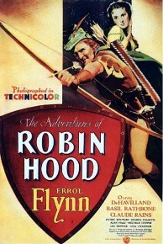
Social Activity: Movie Event
At 1 p.m. (after Elder Lunch) we will show the classic 1938 movie Robin Hood, starring Errol Flynn and Olivia de Havilland. All are welcome to attend.

Notices

Member update
Ron LeBlanc is presently in the Maine Veterans Home recovering from surgery. He would welcome calls or cards at Maine Veteran’s Home, 310 Cony Rd, Augusta, ME 04330 or Phone: (207) 622-2454.
HOLIDAY FAIR – THANKS!
Thank you, everyone who helped with our successful Holiday Fair! We exceeded our fundraising goal and raised $838.60 for our operations budget! We could not have done it without you. Next year, Martha Naber and Nancy Fritz will manage this event.

Chocolate Auction
NeXT SATURDAY - Dec. 16, 5 - 8 p.m.
Get ready to take home a chocolate delight for dinner. Gary Chapin will play his feel-good music while the judges deliberate. Who will bid the highest to take home a scrumptious chocolate dessert? All contributions are welcomed. Please sign up in the Fellowship Hall. Our goal is 20 chocolate entries (cookies, cakes, desserts).

Last year’s contributors were: Palmer, Booth, Cairn, Pinette, McCown, Chapin, Gottlieb, Lombard, Booth, Harvey, Faulkner, Bierce, Rev. Carie, and Bonk.

Thank you, everyone! --Catherine and Heather

DON’T MISS NEXT SUNDAYs Faith Café
Caroling ALL ARE INVITED:
WE hope you join us for our next Faith Café from 2:30 – 5:30 p.m. on Sunday, December 17. We will spread out into local neighborhoods to sing carols and spread cheer. Among our destinations are the homes of Nancee Campbell and Maggie Ricker. After caroling, everyone returns to the church for refreshments and games. Questions, contact Hannah at 293-9377 or hannahuu3@fairpoint.net.

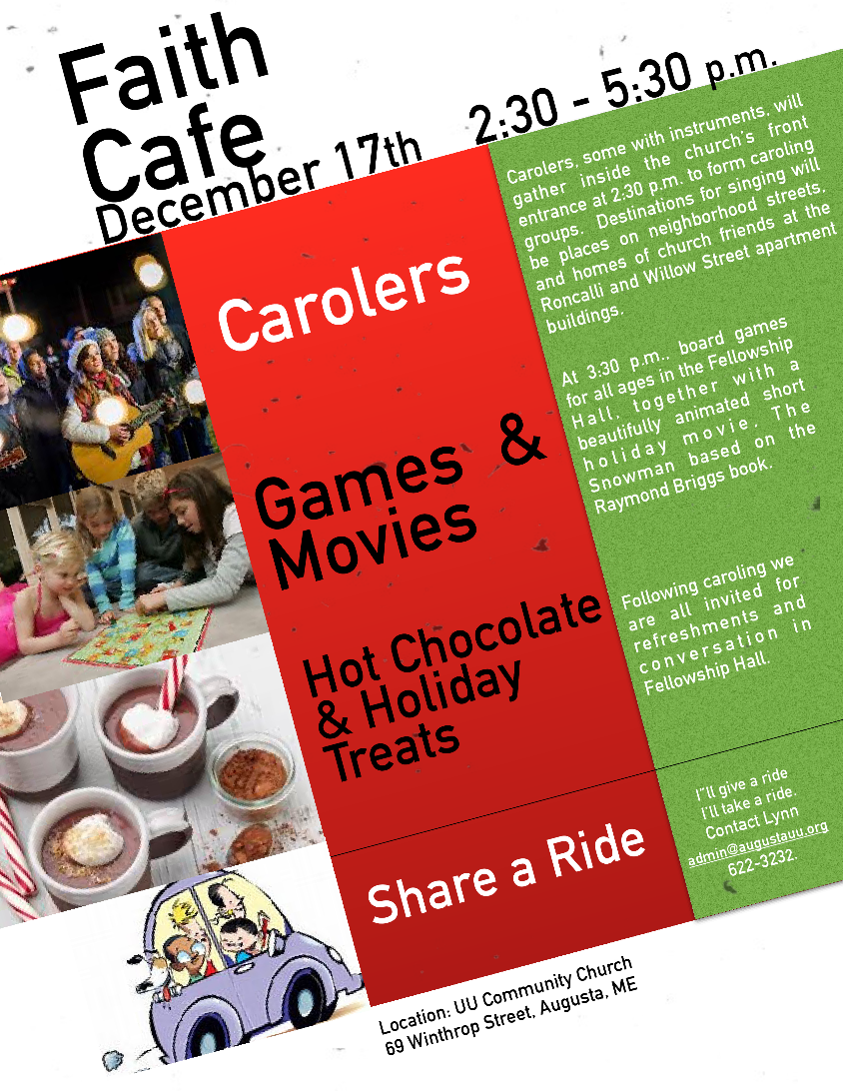
JOIN US for Caroling F-U-N!!
This Week at UUCC …

Monday, December 11, 2017
Private Piano Lessons, 2:30-6:00 p.m., C-Sanct
UUCC Common Read – Option 1 (Waking up White),
6:30-8:00 p.m., C-FH
Peaceful Heart Sangha, 6:30-8:00, C-Sanct
Join this mindfulness meditation group for sitting and walking meditation, readings and sharing in the sanctuary.

Tuesday, December 12, 2017
Small Group Ministry, 10:00 a.m., Off Premises
Al-ANON, Noon, C-Rbsn
Finance Committee Meeting, 5:30 p.m., C-Rbsn

Wednesday, December 13, 2017
Seasoned Souls, 10:30a.m. – Noon, C-FH
Gentle Yoga, 5:00 p.m., C-FH
Everyone is welcome to Wednesday Yoga at the UUCC. No experience needed; just curiosity. People are welcome to drop in, come every once and a while, or become regular attenders. Classes are FREE.
Pastoral Ministry Team Meeting, 5 p.m., J-MS
SAGE Elder Dinner, 7-8 p.m., C-FH

Thursday, December 14, 2017

A Quiet Refuge: Cultivating healing and wholeness
in a complicated world
--Are you exhausted? Lonely? Afraid?
Anxious? Depressed?
--Are you tired of just coping with one thing after another?
--Are you grieving the absence of a loved one?
--Are you Unemployed? Navigating crisis?
--Are you overwhelmed by life circumstance or world events?
--Is this season of lights and merriment simply more than you can bear?

If you answered yes - then this time of healing and restoration is for you. Please join us from 6-7 p.m. in the Sanctuary for a time of quiet facilitated reflection.

Kennebec Advocacy Team Meeting, 6:00 p.m., C-Rbsn

Friday, December 15 2017
In-Kind: Horizon Program Luncheon, 10 a.m., C-FH

Saturday, December 16, 2017
UUCCOO Rehearsal, 8:30-10:30 a.m., C- Sanct
CANMP Boot Bonanza Event, 9:00 – 10:00 a.m., C-FH
CANMP Women’s Talk and Tea, 10 a.m. – Noon, C-FH
Private Piano Lessons, 12:45-6:00 p.m., C-Sanct
Fundraising: Chocolate Auction, 5:00 p.m., C-FH
Come join the sweet fun of a chocolate auction including a healthy mix of traditional music played by Gary Chapin. Join us as we enjoy a great concert with the chocolate items being auctioned off between musical segments.

Sunday, December 17, 2017
Services at 9:15 & 11:00 a.m. “What’s in a Name”**
Rev. Carie Johnsen
UUCC Common Read – Option 2 (Waking up White),
12:30-2:00 p.m., C-FH
Faith Café: Caroling, 2:30-5:30 p.m., C-FH
Flip page for Info on the Faith Café
Private Rental, 6:30-9:30 p.m., C-Sanct

** Let’s explore the Unitarian Universalist Sources together. What name do you give to that which cannot be fully known? To what source(s) do you turn to guide, restore, and sustain your living? This interactive service will make room for the sciences and poetry, the mystics and the seekers, the cynics and the faithful.

Upcoming Events

Tuesday, Dec. 19th, Book Group: Christ for UU’s
Group 1 meets 2:00-4:00 p.m. in C-FH
Group 2 meets 6:00 – 8:00 p.m. in C-FH

Thursday, Dec. 21st, Board Meeting, 6 p.m., C-FH

Sunday, Dec. 24th, Special Christmas Eve Service,
A Christmas Eve Tradition: Carols, Light, and Readings
December 24, 2017 - 5:00 p.m.
Our annual Christmas Eve Service offers people of all ages the opportunity to center their spirit around the many gifts of the holiday season: peace and joy, light and love.

Wednesday, Dec. 27th, Craft Circle, 2-4 p.m., C-FH

UUCC Office Hours

UUCC Office Hours <hours for next week>
Monday ----------------------------------<No office hours>
Tues. Wed. AND Thurs. ---------9:00 am to 4:00 pm
Friday -------------------------------------< No office hours >

Rev. Carie’s Office Hours:
Monday No office Hours
Tuesday 1:00 pm – 6:00 pm
Wednesday 2:00 pm – 6:00 pm
Thursday No office Hours (Writing Day)
<other hours available by appointment>

Rev. Johnsen: 623-3663 or (508) 221-5295 or revcariejohnsen@gmail.com

Caring Cooperative support, contact Rev. Carie Johnsen.
Sunday Services / Staff Contact information:

Office Administrator, Lynn M. Smith, admin@augustauu.org, Phone 622-3232

Youth Advisor, Monique McAuliffe youthadvisor@augustauu.org

Sunday Morning Religious Exploration Coordinator, Brigid Chapin, SundayREcoordinator@augustauu.org

Music Director, Bridget Convey, musicdirector@augustauu.org

